


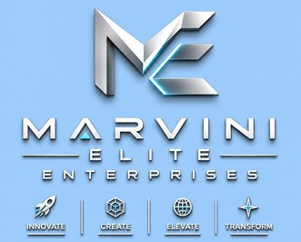

Our Ref:..................................
Your Ref:..................................

1
Ayi Mensah, Adjacent Arts Village
DIGITAL ADDRESS: E3-741-1600
+233208818137
marvinieliteenterprise@gmail.com
Technology Solutions Development, Consultancy and Training, Event Organisation, Innovation and Agric Engineering

2

Ayi Mensah, Adjacent Arts Village
DIGITAL ADDRESS: E3-741-1600
+233208818137
marvinieliteenterprise@gmail.com
Technology Solutions Development, Consultancy and Training, Event Organisation, Innovation and Agric Engineering

